May 4th – May 7th | Monday | Tuesday | Wednesday | Thursday
Math | Watch this video for an introduction to partitioning shapes:  https://www.youtube.com/watch?v=_cdR1ZEqWcY  Then complete the practice problems below (2 pages) | Through Clever, log into BrainPopJr. And watch “Basic Parts of a Whole”.  Next, watch this follow-up video:  https://www.youtube.com/watch?v=0lSTXtwPuOU  Then complete the practice problems below (2 pages) | Watch this video on partitioning:  https://www.youtube.com/watch?v=SpL81P06aPs  Then complete the practice problems below (2 pages)  *No Zoom Lesson today!* | Watch this video on partitioning:  https://learnzillion.com/lesson_plans/5636-partition-a-circle-into-two-three-or-four-equal-shares/  Then complete the practice problems below (2 pages)
Reading | Read both articles about recycling, fill out the Venn Diagram, and answer the questions.  (Included below, or on the blog) | Read both articles about penguins, fill out the Venn Diagram, and answer the questions.  (Included below, or on the blog) | Read both articles about video games, fill out the Venn Diagram, and answer the questions.  (Included below, or on the blog) | Read both articles about ocean animals, fill out the Venn Diagram, and answer the questions.  (Included below, or on the blog)
Writing | Watch this video to review how to state your opinion and support with reasons. https://www.youtube.com/watch?v=GXIr-e19UyQ  Then answer the prompt: “Would you rather give a gift OR receive a gift?” Remember to include at least 2 reasons WHY. | Answer the prompt: “Would you rather be super stretchy OR have super speed?” Remember to include at least 2 reasons WHY.  Go back through your opinion piece and check for proper capitalization and punctuation. | Answer the prompt: “Would you rather be as small as an ant OR as big as a tree?” Remember to include at least 2 reasons WHY.  Go back through your opinion piece and check for proper capitalization and punctuation. | Answer the prompt: “Would you rather live on a ship OR live on a plane?” Remember to include at least 2 reasons WHY.  Go back through your opinion piece and check for proper capitalization and punctuation.
Phonics | Watch this video to learn about contractions.  https://www.youtube.com/watch?v=gubPH3WEurg  Then, use the tic tac toe board and choose one activity to do with these words:  there’s we’ve  he’ll here’s  I’ve let’s  don’t you’re  I’m shouldn’t | Watch this video to learn about contractions.  https://www.youtube.com/watch?v=FGf-SNfbtAQ  Then, use the tic tac toe board and choose one activity to do with these words:  there’s we’ve  he’ll here’s  I’ve let’s  don’t you’re  I’m shouldn’t | Watch this video to learn about contractions.  https://www.youtube.com/watch?v=7UdDjpGmx-0  Then, use the tic tac toe board and choose one activity to do with these words:  there’s we’ve  he’ll here’s  I’ve let’s  don’t you’re  I’m shouldn’t | Take a practice spelling test using these words! See how many you can get right.  there’s we’ve  he’ll here’s  I’ve let’s  don’t you’re  I’m shouldn’t
Social Studies | On Social Studies Weekly (through Clever), complete articles with questions:  Week 22: Trade or Barter  - Trade or Barter?  - Money is Easier – Why? | On Social Studies Weekly (through Clever), complete articles with questions:  Week 22: Trade or Barter  - Countries Trade  - We Earn So We Can Buy | On Social Studies Weekly (through Clever), complete articles with questions:  Week 22: Trade or Barter  - Making Choices  - Traveling Bananas | On Social Studies Weekly (through Clever), complete articles with questions:  Week 22: Trade or Barter  - Draw a Picture  - Write a Sentence

PHONICS
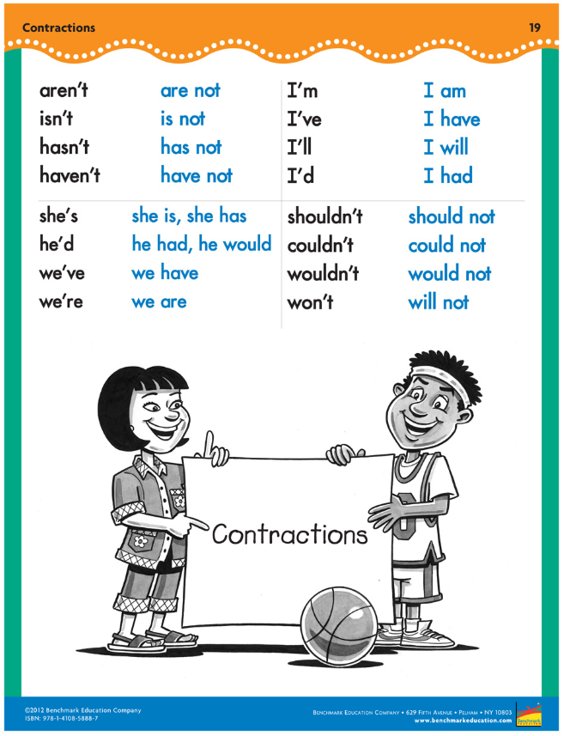

Math
Monday:
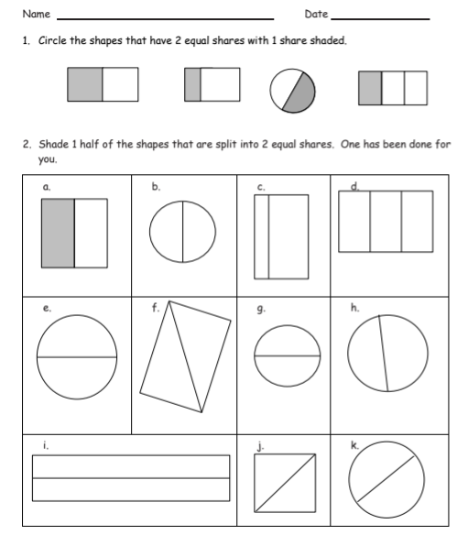

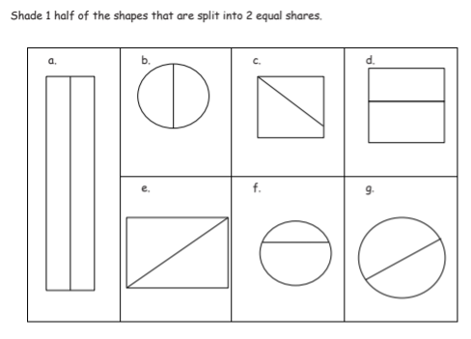

Tuesday
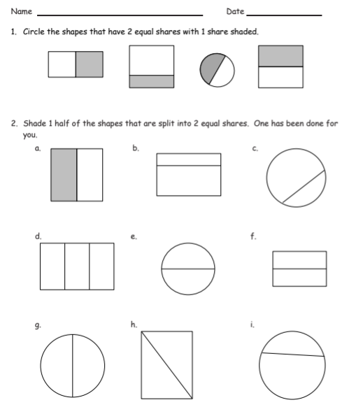

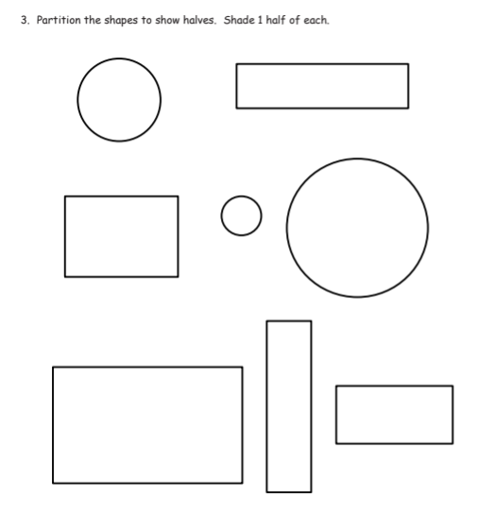

Wednesday

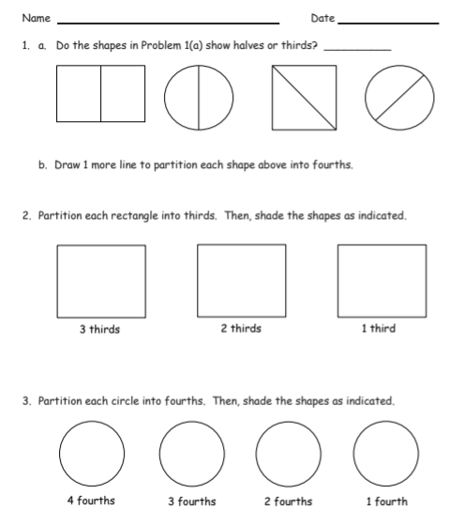

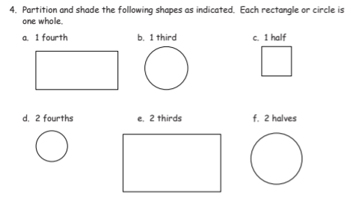

Thursday (It looks the same as Wednesday, but I promise it’s not!)

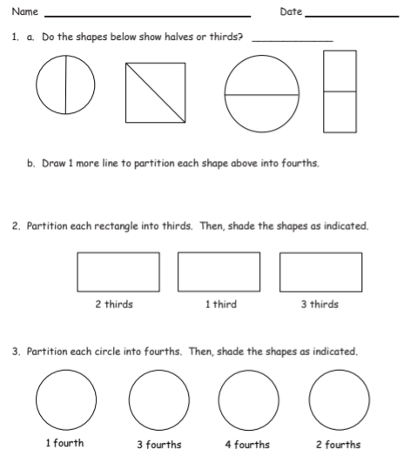

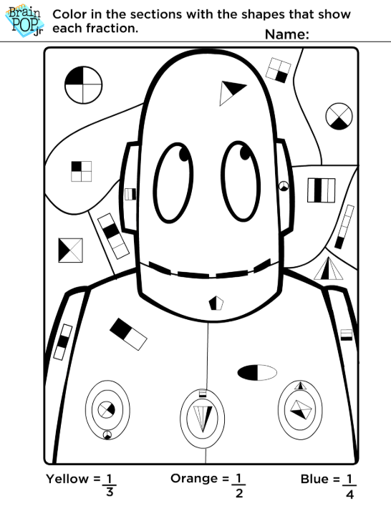

Reading
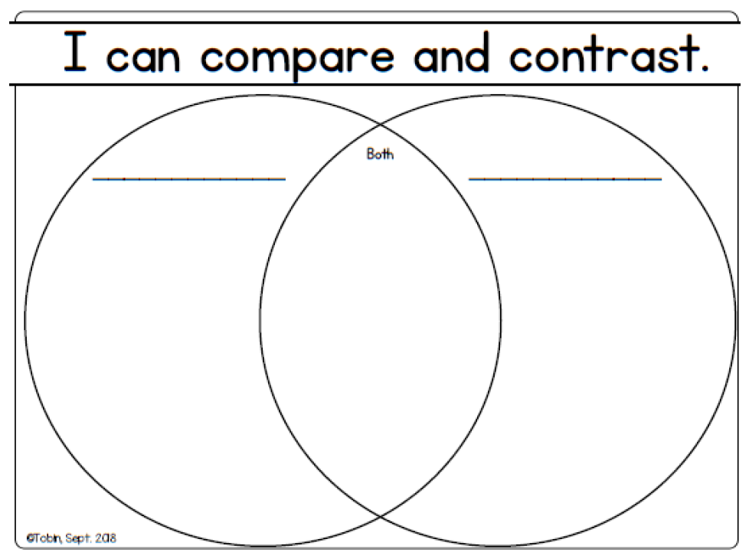

Monday
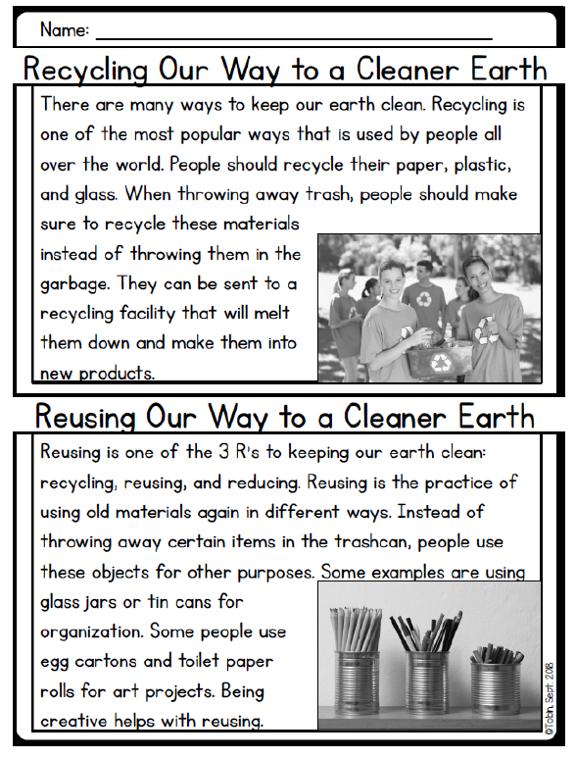

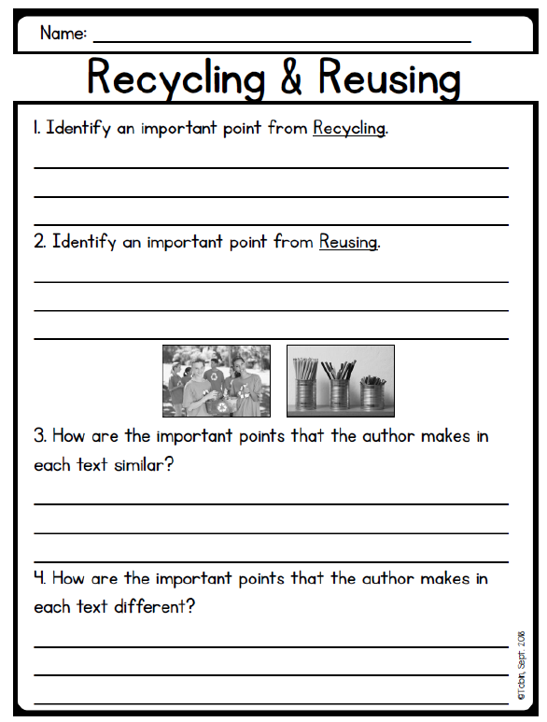

Tuesday
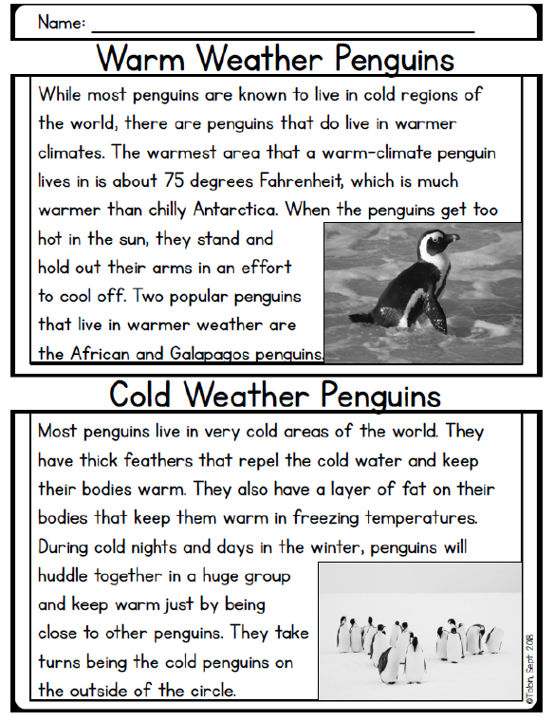

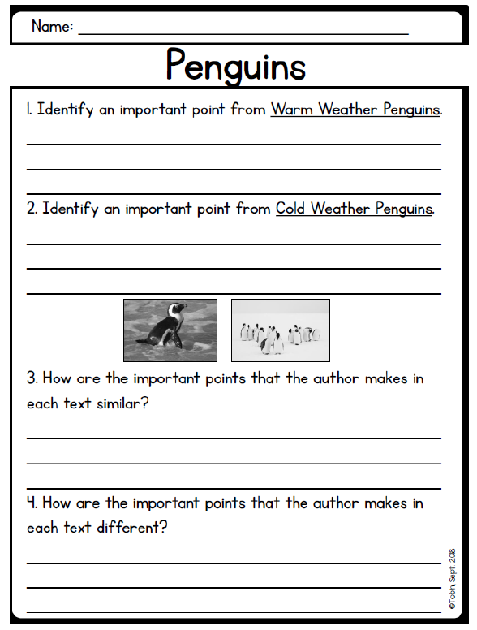

Wednesday

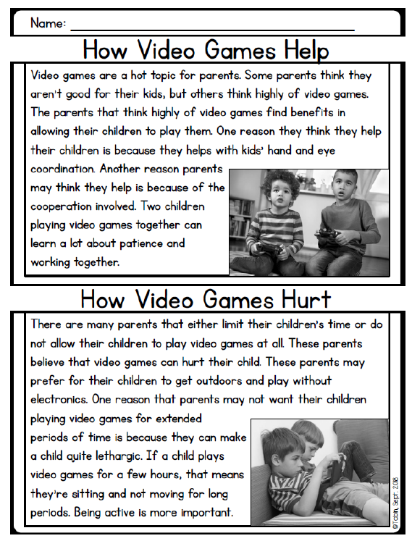

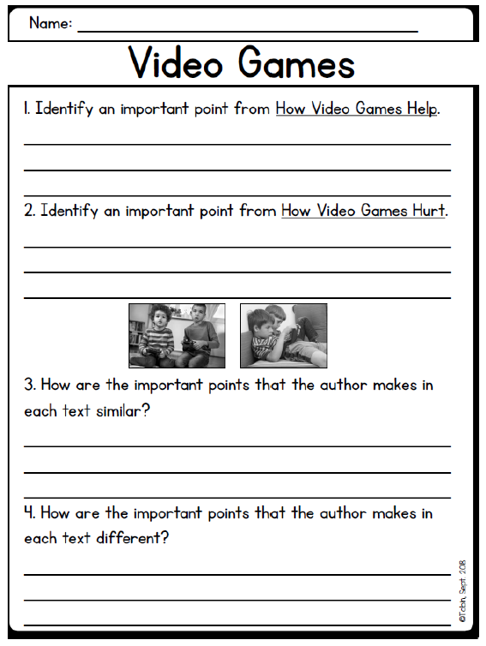

Thursday
