May 11th – May 15th | Monday | Tuesday | Wednesday | Thursday
Math | Watch this video for an introduction to arrays:  https://www.youtube.com/watch?v=lryvMT8cbeA  Then complete the practice problems below (2 pages) | Through Clever, log into BrainPopJr and watch “Arrays”  Next, watch this follow-up video:  https://www.khanacademy.org/math/early-math/cc-early-math-add-sub-20/cc-early-math-repeated-addition/v/repeated-addition-example  Then complete the practice problems below (2 pages) | Through Clever, log into BrainPopJr and watch “Repeated Addition”  Then complete the practice problems below (2 pages) | Watch this video to review  Arrays and Repeated Addition equations:  https://www.youtube.com/watch?v=e0tMOj5wGUI  Then complete the practice problems below (2 pages)
Reading | Watch this video to review main idea and key details: https://www.youtube.com/watch?v=4LOXHIrkFJQ  Read the passage about bees and write the main idea and key details in the ice cream scoop organizer below the passage. | Through Clever, log into BrainPopJr. and watch the “Main Idea” video.  Read the passage about thunderstorms and write the main idea and key details in the ice cream scoop organizer below the passage. | Review main idea and key details by studying the anchor chart example (included under Wednesday below).  Read the passage about Great White sharks and then fill out the graphic organizer. | Read the passage about bees (different from Monday) and then fill out the graphic organizer.
Writing | Watch this video to review how to provide reasons and examples for your opinion statement. https://www.youtube.com/watch?v=X1e8Zg-fYgE  Then answer the prompt: “Would you rather visit the past or visit the future?” Remember to include at least 2 reasons WHY. | Answer the prompt: “Would you rather live in a big city or live on a farm in the country?” Remember to include at least 2 reasons WHY.  Go back through your opinion piece and check for proper capitalization and punctuation. | Answer the prompt: “Would you rather be very tall or be very strong?” Remember to include at least 2 reasons WHY.  Go back through your opinion piece and check for proper capitalization and punctuation. | Answer the prompt: “Would you rather write a book or act in a movie?” Remember to include at least 2 reasons WHY.  Go back through your opinion piece and check for proper capitalization and punctuation.
Phonics | Watch this video for an introduction to singular and plural nouns:  https://www.khanacademy.org/humanities/grammar/parts-of-speech-the-noun/grammar-nouns/v/introduction-to-singular-and-plural-nouns-the-parts-of-speech-grammar-khan-academy  Then, use the tic tac toe board and choose one activity to do with these words:  Peach mouse  Peaches mice  Box tooth  Boxes teeth  Penny wife  Pennies wives | Watch this video to learn about  Regular plural nouns:  https://www.youtube.com/watch?v=B75ha9_CW9Q  Then, use the tic tac toe board and choose one activity to do with these words:  Peach mouse  Peaches mice  Box tooth  Boxes teeth  Penny wife  Pennies wives | Watch this video to learn about  IRREGULAR plural nouns:  https://www.youtube.com/watch?v=jaHLqulGUYQ  Then, use the tic tac toe board and choose one activity to do with these words:  Peach mouse  Peaches mice  Box tooth  Boxes teeth  Penny wife  Pennies wives | Take a practice spelling test using these words! See how many you can get right.  Peach mouse  Peaches mice  Box tooth  Boxes teeth  Penny wife  Pennies wives
Social Studies | On Social Studies Weekly (through Clever), complete articles with questions:  Week 32: Time, Continuity, and Change  -Our State Changed  -Good in People | On Social Studies Weekly (through Clever), complete articles with questions:  Week 32: Time, Continuity, and Change  -The Good in People  -Preserving Our Cultures | On Social Studies Weekly (through Clever), complete articles with questions:  Week 32: Time, Continuity, and Change  - Many Cultures Together  - Old or New Things | On Social Studies Weekly (through Clever), complete articles with questions:  Week 32: Time Continuity and Change  - Ways I Have Changed  - Ways I Can Improve

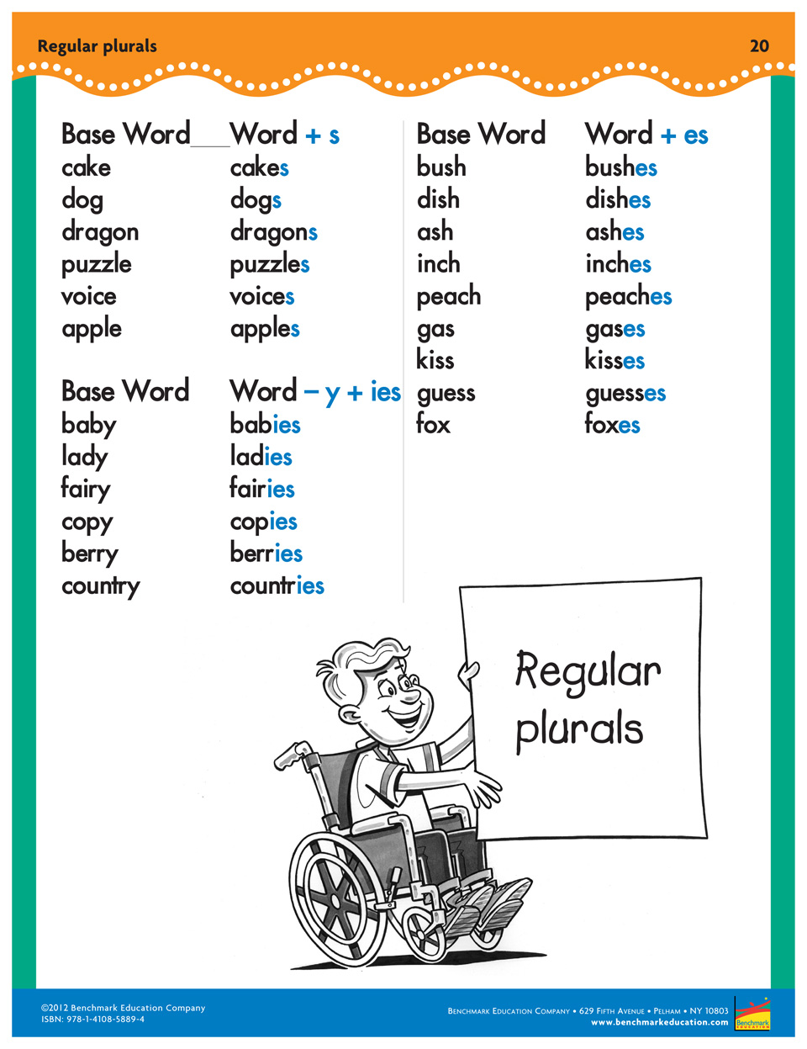
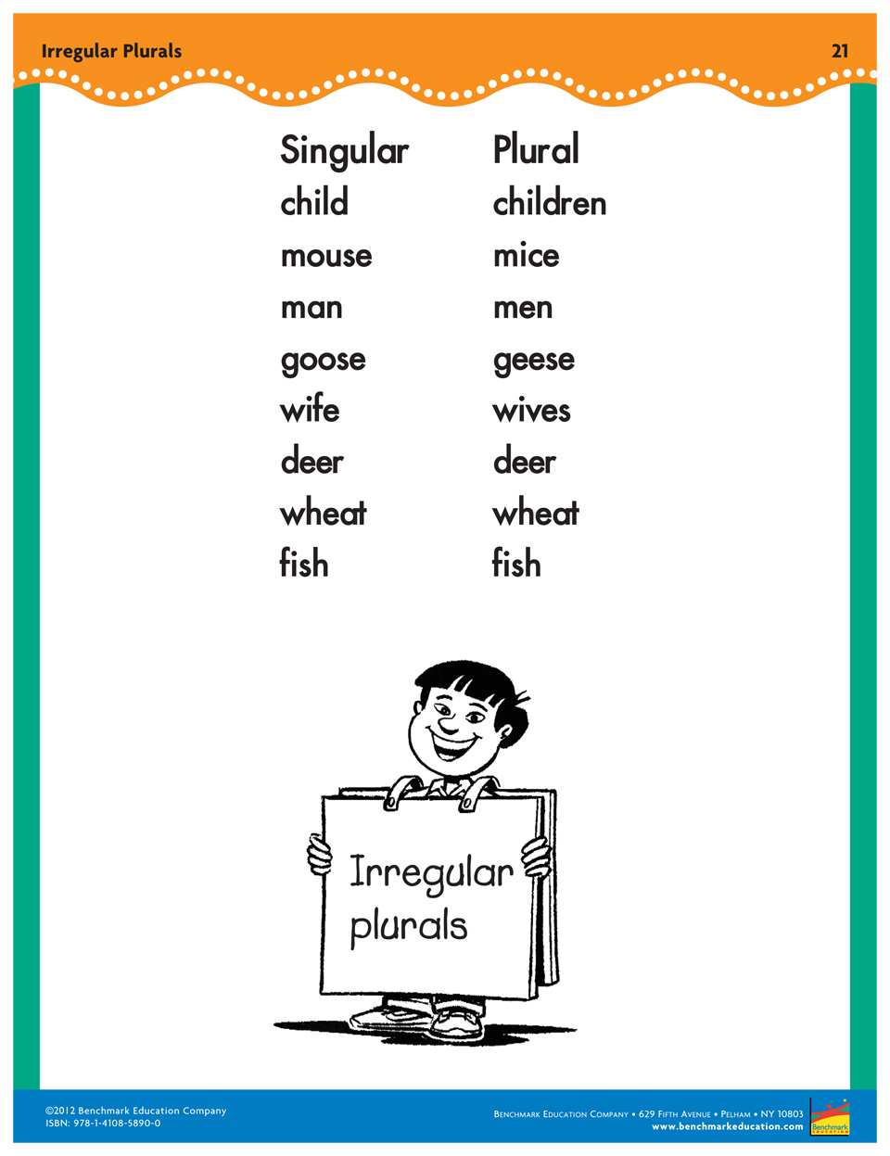
Math
Monday:

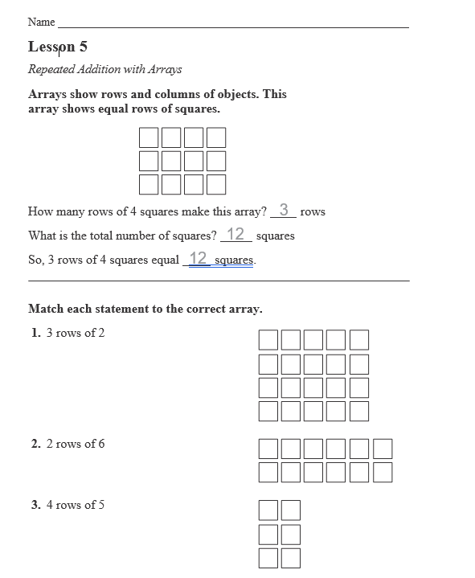

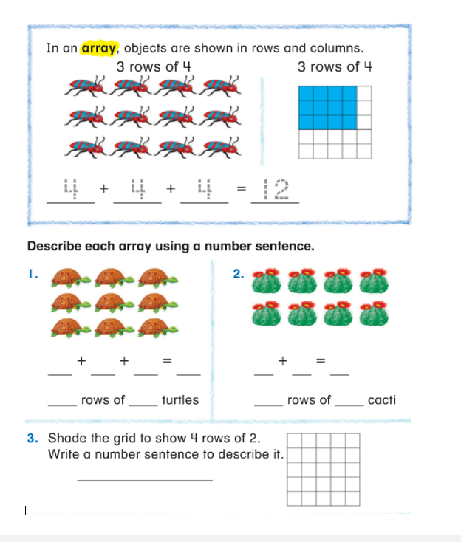

Tuesday
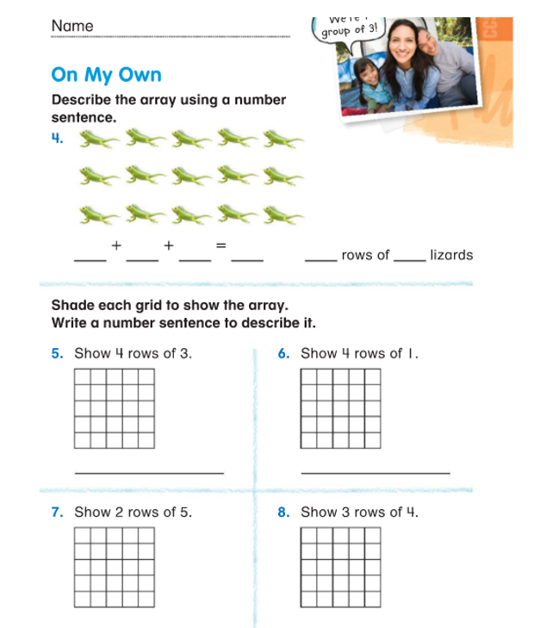

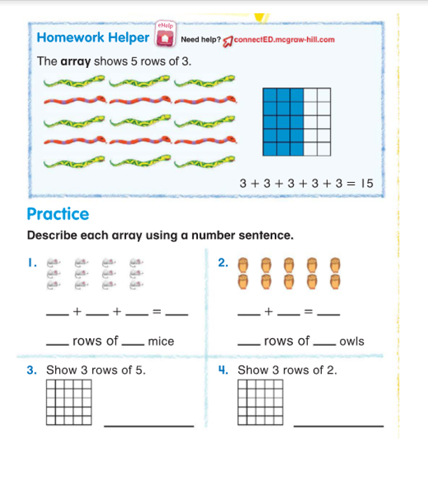

Wednesday
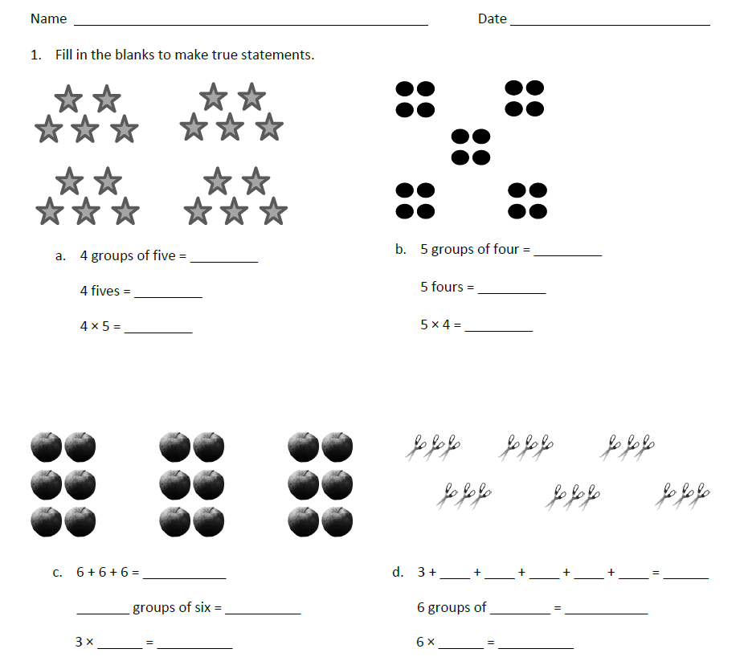

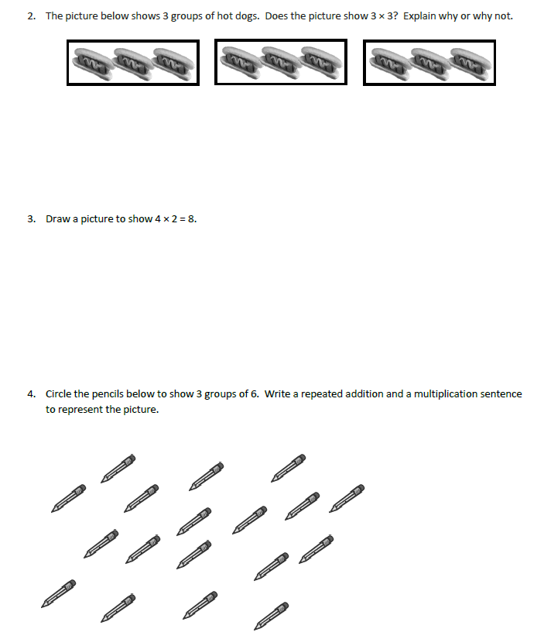

Thursday
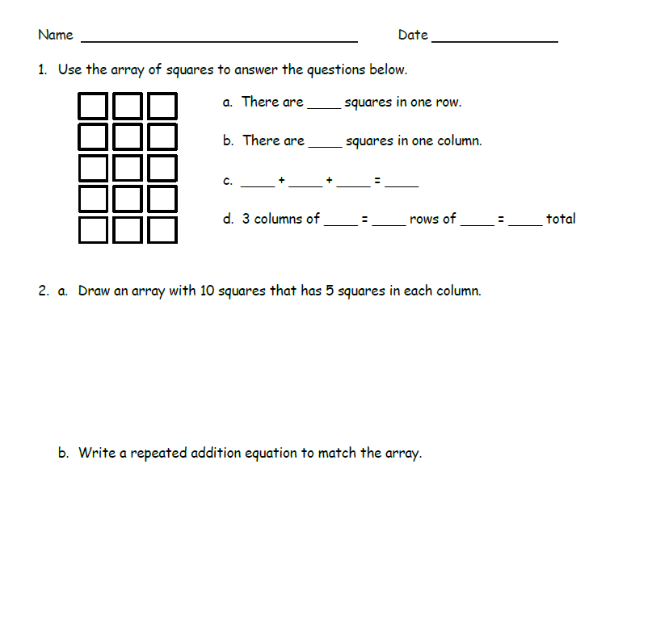

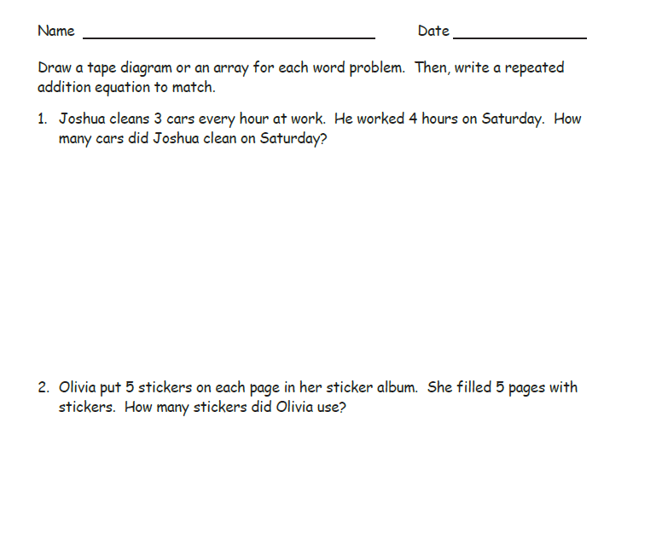

Reading
Monday
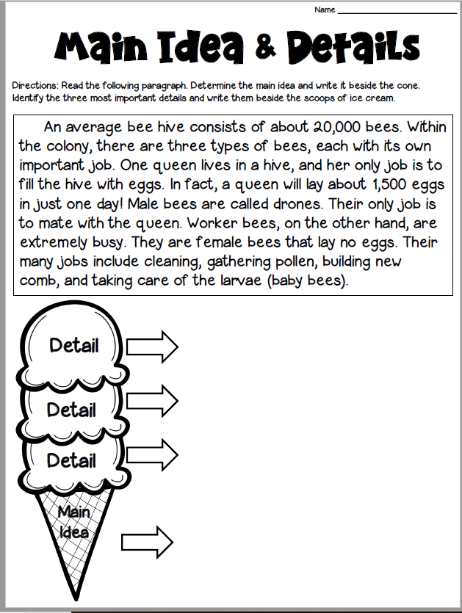

Tuesday
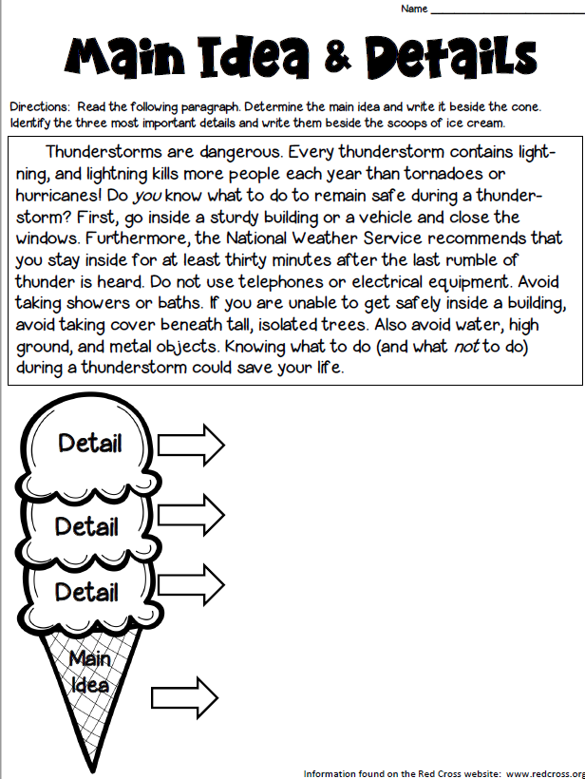

Wednesday

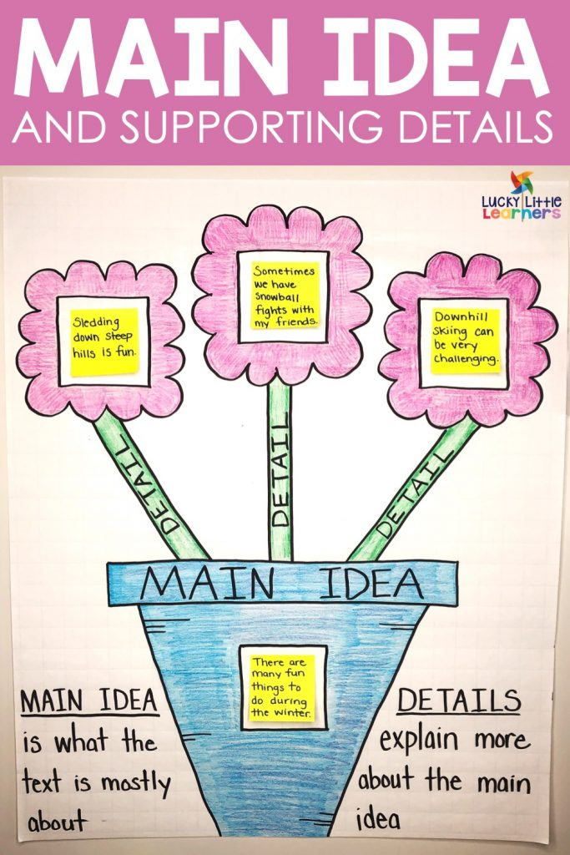

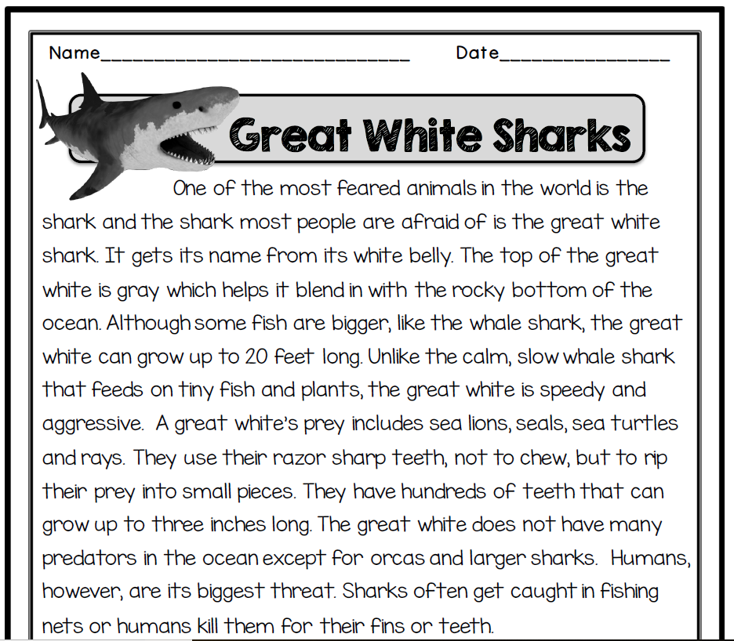
Wednesday

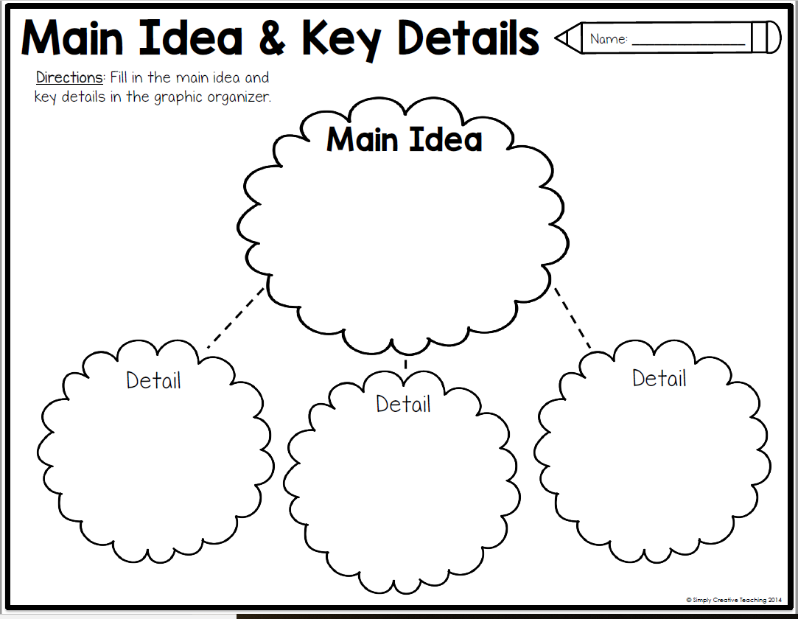

Thursday
