April 27-April 30 | Monday | Tuesday | Wednesday | Thursday
Math | Watch Mrs. Pypiak’s video (also on the blog) about the result unknown problems.  https://www.youtube.com/watch?v=jVmM75gOe0I  Solve the Monday word problems. (written below this calendar) | Watch Mrs. Pypiak’s video (also on the blog) about the change unknown problems.  https://www.youtube.com/watch?v=aS1p_eDnwD4  Solve the Tuesday word problems. (written below this calendar) | Watch Mrs. Pypiak’s video (also on the blog) about the start unknown problems.  https://www.youtube.com/watch?v=bGBgJCWYQXo  Solve the Wednesday word problems. (written below this calendar) | Create your own word problems! Make at least one with a result unknown, one with a change unknown, and one with a start unknown. Have a family member solve them!
Reading | Watch the video below (also linked on the blog) to see how to complete the reading assignments this week:  https://www.youtube.com/watch?v=Gt4LGhfmIq4  Then, try it yourself! Finish the “Comparing T Rex” questions on your own. | Read “Comparing Sea Turtles” and answer the questions. | Read “Comparing Shark Teeth” and answer the questions. | Read “Comparing Hockey” and answer the questions.
Writing | This week, you will need to use the story you wrote last week (or any other story you’ve written while at home).  Today, you will be searching for adjectives! Watch this video about adjectives, and then circle your adjectives in your story. Try to have at least 3 good adjectives. Add one more adjective to your story today!  https://www.youtube.com/watch?v=QxoDGlPUmyU | Use the same story you did yesterday. We are going to look for adverbs now. You might not have as many of these in your story, but circle what you have. Then try to add at least one more!  https://www.youtube.com/watch?v=yo8pzuE97EA | Now look for verbs! Watch this video first and then circle your verbs. Try to have at least 3 action verbs. Add one more verb to your story today!  https://www.youtube.com/watch?v=otpjb5y4wDo | Today, let’s look for proper nouns. Watch this video, and then circle your proper nouns. Try to have at least 3 in your story. Add one more proper noun to your story!  https://www.youtube.com/watch?v=yuuyewH_cpI
Phonics | Watch this video to learn about silent letters.  https://www.youtube.com/watch?v=ss9r236LRcw  Then, use the tic tac toe board and choose one activity to do with these words:  wrap lamb  knee gnaw  knight limb  write rhino  thumb wrist | Watch this video to learn about silent letters.  https://www.youtube.com/watch?v=6p4hRbPQC2w&t=2s  Then, use the tic tac toe board and choose one activity to do with these words:  wrap lamb  knee gnaw  knight limb  write rhino  thumb wrist | Watch this video to learn about silent letters.  https://www.youtube.com/watch?v=sx_tv6LcOJA  Then, use the tic tac toe board and choose one activity to do with these words:  wrap lamb  knee gnaw  knight limb  write rhino  thumb wrist | Take a practice spelling test using these words! See how many you can get right.  wrap lamb  knee gnaw  knight limb  write rhino  thumb wrist
Social Studies | On Social Studies Weekly (through Clever), complete articles with questions:  Week 27: Economic Choices  -Making Choices  -Making a Living | On Social Studies Weekly (through Clever), complete articles with questions:  Week 27: Economic Choices  -Work, Now and Long Ago  -Scarcity, Long Ago and Today | On Social Studies Weekly (through Clever), complete articles with questions:  Week 27: Economic Choices  -Different Choices Today  -How to Read Tables | On Social Studies Weekly (through Clever), complete articles with questions:  Week 27: Economic Choices  -Write a Sentence

PHONICS
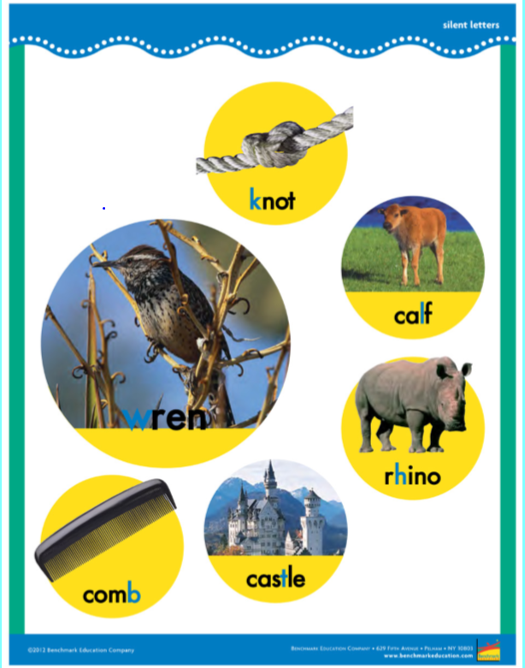

See below for the math problems!

Monday word problems

1. Chance had 45 sour patch kids. Harvey ate 24 of them. How many sour patch kids does Chance have now?

2. Tenny had 34 dolls. She gave 18 away to her sister. How many dolls does Tenny have now?

3. Luis draws 51 pictures in the morning. Then he gives Mrs. Weeks 17 of the pictures. How many pictures does Luis have left?

4. Kaitlin has 75 markers. 12 of the markers ran out of ink. How many good markers does Kaitlin have left?

Tuesday

1. Audrey has 34 rabbits in her yard. Then some hop away. Now there are only 11 rabbits in Audrey’s yard. How many rabbits hopped away?

2. Sal has 48 basketballs at his house. He lost some of them. Now Sal has 35 basketballs. How many basketballs did he lose?

3. DeeDee has 62 stickers. She used some to make a card. Now DeeDee has 28 stickers. How many stickers did DeeDee use on the card?

4. Matt has 22 shoes. He gives some to his little brother. Now Matt has 10 shoes. How many shoes did he give to his brother?

Wednesday’s word problems

1. Mike had some soccer balls. He kicked 10 into the woods. Now Mike has only has 31 soccer balls. How many soccer balls did he have at the beginning?

2. Jordan had some mini pancakes. Then she ate 13 of them. Now Jordan has 10 mini pancakes. How many pancakes did Jordan have at the beginning?

3. Felicita had some stuffed animals. Then she gave 20 to her sister. Now Felicita has 43 stuffed animals. How many stuffed animals did Felicita have at the beginning?

4. Tim had some Godzilla figures. He lost 15 of them. Now Tim has 46 Godzilla figures. How many did Tim have at the beginning?

