April 13-17 | Monday | Tuesday | Wednesday | Thursday
Math | Solve the Monday word problems. (written below this calendar)  Watch the video on the blog that Mrs. Pypiak made to help you with this type of problem.  Blog link: http://hollydalegrade2.weebly.com/ | Solve the Tuesday word problems. (written below this calendar)  Watch the video on the blog that Mrs. Pypiak made to help you with this type of problem.  Blog link: http://hollydalegrade2.weebly.com/ | Solve the Wednesday word problems. (written below this calendar)  Watch the video on the blog that Mrs. Pypiak made to help you with this type of problem.  Blog link: http://hollydalegrade2.weebly.com/ | Solve the Thursday word problems. These are a mix of all of the types of word problems we’ve done this week. (written below this calendar)  Blog link: http://hollydalegrade2.weebly.com/
Reading | Visit: https://classroommagazines.scholastic.com/support/learnathome/grades-1-2.html  Complete Week 4 Day 16  OR:  Read the “Talking Ants” passage and answer questions. | Visit: https://classroommagazines.scholastic.com/support/learnathome/grades-1-2.html  Complete Week 4 Day 17  OR:  Read the “George Washington” passage and answer questions. | Visit: https://classroommagazines.scholastic.com/support/learnathome/grades-1-2.html  Complete Week 4 Day 18  OR:  Read the “Growing Strong” passage and answer questions. | Visit: https://classroommagazines.scholastic.com/support/learnathome/grades-1-2.html  Complete Week 4 Day 19  OR:  Read the “Nature’s Helpers” passage and answer questions.
Writing | http://www.scholastic.com/teachers/story-starters/  If you go to this website, it will let you spin a wheel to get story ideas! Spin the wheel today and write about it!  OR  You can do the writing activity down below the calendar – it’s called ROLE. | http://www.scholastic.com/teachers/story-starters/  Spin the wheel again and write a different story.  OR  You can do the writing activity down below the calendar – it’s called ROLE. Pick a new one for today. | http://www.scholastic.com/teachers/story-starters/  Spin the wheel again and write a different story.  OR  You can do the writing activity down below the calendar – it’s called ROLE. Pick a new one for today. | Pick your favorite writing piece from this week. Edit your piece – check for capitals, punctuation, and spelling!  Publish your imaginative narrative! Type it up on the computer, or create a book with illustrations.  Send me a picture or video of your published copy on Dojo!
Phonics | Watch this video to learn about the different sounds “oo” can make.  https://www.youtube.com/watch?v=onhpxGFgM4s  Then, use the tic tac toe board and choose one activity to do with these words:  moon wood  spoon shook  tooth cook  raccoon barefoot  seafood notebook | Watch this video to learn about the different sounds “oo” can make.  https://www.youtube.com/watch?v=hDJQM9XxsCc  Then, use the tic tac toe board and choose one activity to do with these words:  moon wood  spoon shook  tooth cook  raccoon barefoot  seafood notebook | Watch this video to learn about the different sounds “oo” can make.  https://www.youtube.com/watch?v=p2cshyu82vk  Then, use the tic tac toe board and choose one activity to do with these words:  moon wood  spoon shook  tooth cook  raccoon barefoot  seafood notebook | Watch this video to learn about the different sounds “oo” can make.  https://www.youtube.com/watch?v=axwBqTBJIF4  Then, use the tic tac toe board and choose one activity to do with these words:  moon wood  spoon shook  tooth cook  raccoon barefoot  seafood notebook
Social Studies | On Social Studies Weekly (through Clever), complete articles with questions:  Week 17: Scarcity  -Scarcity  -Supply and Demand | On Social Studies Weekly (through Clever), complete articles with questions:  Week 17: Scarcity  -Apples and Apple Juice  -Oranges and Orange Juice | On Social Studies Weekly (through Clever), complete articles with questions:  Week 17: Scarcity  -Benefits  -Opportunity Cost | On Social Studies Weekly (through Clever), complete articles with questions:  Week 17: Scarcity  -Draw a Picture

PHONICS
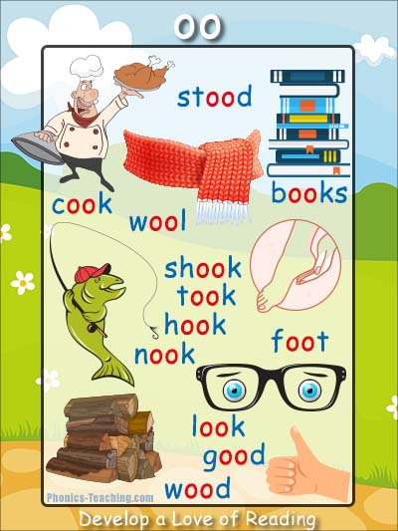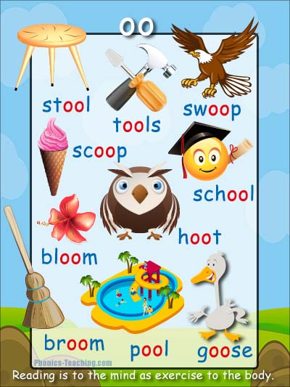
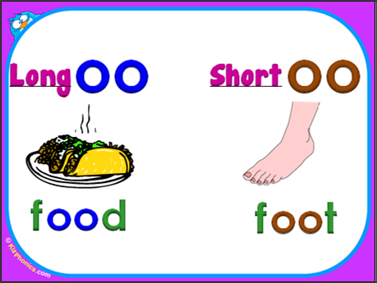

WRITING
Choose 4 numbers between 1-8.
ROLE | OCCASION | LOCATION | EMOTION

Your four numbers choose your Role, Occasion, Location, and Emotion below. Use these elements to write a fictional narrative.
ROLE | OCCASION | LOCATION | EMOTION
1.Farmer | 1.Birthday | 1.Castle | 1.Happy
2.Teacher | 2.Holiday | 2.Ship | 2.Sad
3.Scientist | 3.Breakfast | 3.School | 3.Tired
4.Astronaut | 4.Wedding | 4.Forest | 4.Angry
5.Dog | 5.Field Trip | 5.Zoo | 5.Crabby
6.King | 6.Soccer Game | 6.Beach | 6.Worried
7.Athlete | 7.Concert | 7.Outer Space | 7.Excited
8.Pirate | 8.Party | 8.Walmart | 8.Scared

Example:
ROLE | OCCASION | LOCATION | EMOTION
4. Astronaut | 1.Birthday | 8. Walmart | 8. Scared

I would write a story about a Scared Astronaut having a Birthday at Walmart.

MATH

Monday word problems

1. Carlos had 45 sour patch kids. Janet gave him 39 more sour patch kids. How many sour patch kids does Carlos have now?

2. Jenny had 14 dolls. She bought 28 more at the store. How many dolls does Jenny have now?

3. Mason draws 25 pictures in the morning. Then he draws 24 more after lunch. How many pictures did Mason draw?

4. Kaitlin buys 38 markers at the store. Her mom gives her 12 more markers. Now how many markers does Kaitlin have?

Tuesday word problems

1. Daisy has 14 rabbits in her yard. Then some more hop over. Now there are 29 rabbits in Daisy’s yard. How many rabbits hopped over?

2. Khalid has 21 basketballs at his house. He bought some more at the store. Now Khalid has 34 basketballs. How many basketballs did he buy at the store?

3. Kyranae has 29 stickers. Her mom gives her some more. Now Kyranae has 52 stickers. How many stickers did her mom give her?

4. Devan has 18 shoes. He buys more shoes at the store. Now Devan has 32 shoes. How many shoes did he buy at the store?

Wednesday’s word problems

1. Tony had some soccer balls. He bought 20 more at the store. Now Tony has 41 soccer balls. How many soccer balls did he have at the beginning?

2. Kaylee had some pancakes. Then her mom made 10 more pancakes. Now Kaylee has 18 pancakes. How many pancakes did Jordan have at the beginning?

3. Sophia had some stuffed animals. Then she found 12 in her room. Now Sophia has 32 stuffed animals. How many stuffed animals did Felicita have at the beginning?

4. Jack had some Godzilla figures. He got 22 more at the store. Now Jack has 31 Godzilla figures. How many did Jack have at the beginning?

Thursday word problems

1. Nathan was playing with 23 footballs. Then Yuriel gave him 12 more. How many footballs does Nathan have now?

2. Nia had some candy. Then Yaliyah gave her 28 more pieces. Now Nia has 51 pieces of candy. How many pieces did Nia have at the beginning?

3. Christillahna made 18 necklaces. Mia gave her 12 more necklaces. Now how many necklaces does Christillahna have?

4. Cody had 32 lego people. His mom gave him more lego people. Now Cody has 63 lego people. How many lego people did Cody’s mom give him?

